**Assignment - 4**

Tinkercad Task

| Assignment Date | 8 October 2022 |
| --- | --- |
| Student Name | Varshinie Sagarikaa M S |
| Student Roll Number | 111519106167 |
| Maximum Marks | 2 Marks |

**Question-1:**

Write a code and make the connections in wokwi for the ultrasonic sensor. Whenever the distance is less than 100cms send an“Alert” to the IBM cloud and display in the device recent events.

Solution:

#include <WiFi.h>

#include<PubSubClient.h>

voidcallback(char*subscribetopic,byte*payload,unsignedintpayloadLength);

//-------credentialsofIBMAccounts------

#defineORG"rgjkkf"//IBMORGANITIONID

#defineDEVICE_TYPE"MyDevice"//DevicetypementionedinibmwatsonIOTPlatform

#define DEVICE_ID "12345"//Device ID mentioned in ibmwatson IOT Platform

#defineTOKEN"Ammipa@112"//Token

Stringdata3;

charserver[]=ORG".messaging.internetofthings.ibmcloud.com";

charpublishTopic[]="iot-2/evt/Data/fmt/json";

charsubscribetopic[]="iot-2/cmd/test/fmt/String";

charauthMethod[]="use-token-auth";

chartoken[]=TOKEN;

charclientId[]="d:"ORG":"DEVICE_TYPE":"DEVICE_ID;

WiFiClientwifiClient;

PubSubClientclient(server,1883,callback,wifiClient);constint trigPin =5;

const int echoPin = 18;#defineSOUND_SPEED0.034longduration;

floatdistance;voidsetup(){

Serial.begin(115200);

pinMode(trigPin,OUTPUT);

pinMode(echoPin, INPUT);

wificonnect();

mqttconnect();

}

voidloop()

{

digitalWrite(trigPin, LOW);

delayMicroseconds(2);

digitalWrite(trigPin, HIGH);

delayMicroseconds(10);

digitalWrite(trigPin,LOW);

duration = pulseIn(echoPin, HIGH);

distance=duration*SOUND_SPEED/2;

Serial.print("Distance (cm): ");

Serial.println(distance);

if(distance<100)

{

Serial.println("ALERT!!");

delay(1000);

PublishData(distance);

delay(1000);

if(!client.loop()){mqttconnect();

}

}

delay(1000);

}

voidPublishData(floatdist){

mqttconnect();

Stringpayload="{\"Distance\":";

payload+=dist;

payload+=",\"ALERT!!\":""\"Distancelessthan100cms\"";payload+= "}";

Serial.print("Sendingpayload:");

Serial.println(payload);

if(client.publish(publishTopic,(char*)payload.c_str())){

Serial.println("Publishok");

}

else{

Serial.println("Publishfailed");

}

}

voidmqttconnect(){

if (!client.connected()) {

Serial.print("Reconnectingclientto");

Serial.println(server);

while(!!!client.connect(clientId,authMethod,token)){

Serial.print(".");

delay(500);

}

initManagedDevice();

Serial.println();

}

}

voidwificonnect()

{

Serial.println();

Serial.print("Connecting to ");

WiFi.begin("Wokwi-GUEST", "", 6);

while (WiFi.status() !=WL_CONNECTED){delay(500);

Serial.print(".");

}

Serial.println("");

Serial.println("WiFiconnected");

Serial.println("IP address: ");

Serial.println(WiFi.localIP());

}

voidinitManagedDevice(){

if (client.subscribe(subscribetopic)) {

Serial.println((subscribetopic));

Serial.println("subscribe tocmdOK");

}

else{

Serial.println("subscribetocmdFAILED");

}

}

voidcallback(char*subscribetopic,byte*payload,unsignedintpayloadLength)

{

Serial.print("callbackinvokedfortopic:");

Serial.println(subscribetopic);

for(inti=0;i<payloadLength;i++){

//Serial.print((char)payload[i]);

data3+=(char)payload[i];

}

Serial.println("data:"+data3);data3="";

}

**Diagram.json:**

{

"version":1,

"author": "sweetysharon","editor": "wokwi","parts":[

{"type":"wokwi-esp32-devkit-v1","id":"esp","top":-4.67,"left":-114.67,"attrs":{}},

{"type":"wokwi-hc-sr04","id":"ultrasonic1","top":15.96,"left":89.17,"attrs":{}}

],

"connections":[

["esp:TX0","$serialMonitor:RX","",[]],

["esp:RX0","$serialMonitor:TX","",[]],[

"esp:VIN","ultrasonic1:VCC","red",

["h-37.16","v-178.79","h200","v173.33","h100.67"]

],

["esp:GND.1","ultrasonic1:GND","black",["h39.87","v44.04","h170"]],

["esp:D5","ultrasonic1:TRIG","green",["h54.54","v85.07","h130.67"]],

["esp:D18","ultrasonic1:ECHO","green",["h77.87","v80.01","h110"]]

]

}

**Circuit Diagram:**

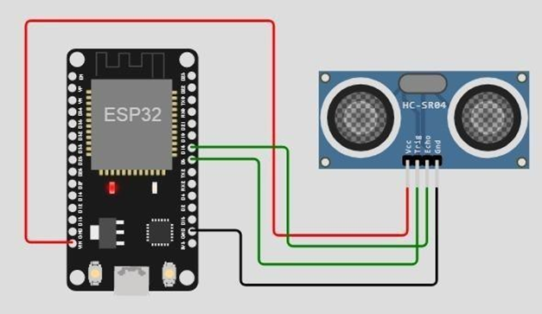

**Output:**

